GAME BOY STUFF

<https://bulbapedia.bulbagarden.net/wiki/Pok%C3%A9mon_data_structure_in_Generation_III>

<https://datacrystal.romhacking.net/wiki/Pok%C3%A9mon_FireRed_and_LeafGreen:RAM_map>

To change pokemon name:

1. Find the pokemon start spot in memory (party pokemon 1 starts at 0x02024284)
2. Go to start of name which is 8 byte offset
3. Names have 10 characters max, so 10 bytes allocated for this.
4. Each letter is represented using the proprietary character set, represented in this chart:

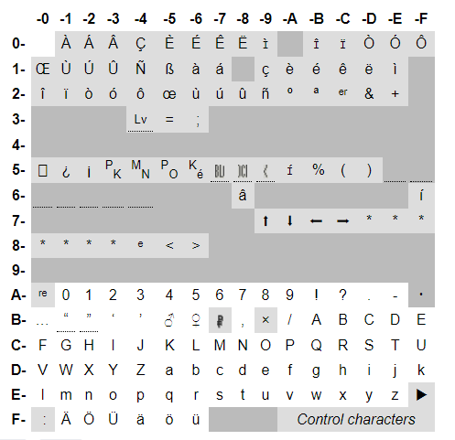

To represent the letter “H”, use the byte combo C2. Space is represented with 00

Change level: offset of 84

MEMORY IS MOSTLY LITTLE ENDIAN (i.e. right to left)

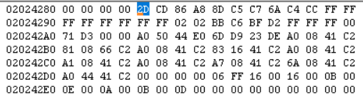

**Mapping of the pokemon:**  
Personality Value: 4 bytes, offset 0-3: A8 86 CD 2D

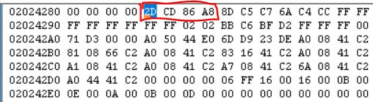

OT ID: 4 bytes, offset 4-7: 6A C7 C5 8D

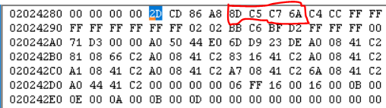

Nickname(strings are big endian): 10 bytes, offset 8-17: C4 CC FFFFFFFFFFFFFFFFFF

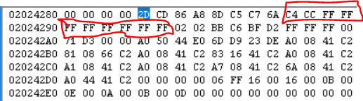

Language: 2 bytes, offset 18-19: 02 02

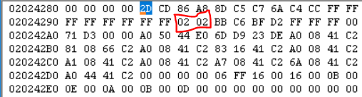

OT name(big endian): 7 bytes, offset 20-26: BB C6 BF D2 FF FF FF

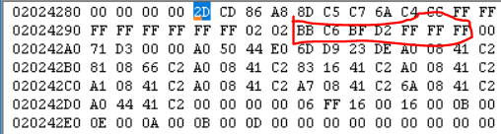

Markings: 1 byte, offset 27: 00

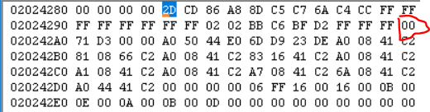

Checksum: 2 bytes, offset 28-29: D3 71

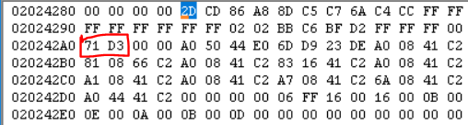

??????: 2 byets, offset 30-31: 00 00 - DONT CARE ABOUT THIS

**DATA SECTION MAPPING GOES HERE - THIS IS FOR ALEX’s SQUIRTLE RIGHT NOW**

The encrypted 48 bytes:

First 12 (Misc)  
Second 12 (Attacks)  
Third 12 (EV)  
Fourth 12 (Growth):

**MISC SECTION(12 bytes):**

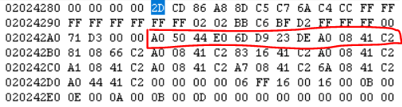

Decryptions for misc:

E0 44 50 A0 ^ **C2 41 08 A0‬ = ‭22 05 58 00‬**

**ATTACK SECTION(12 bytes):**

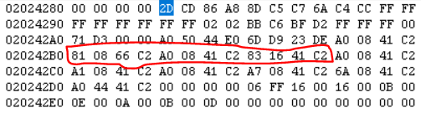

Decryptions for attack:

**EV SECTION(12 bytes):**

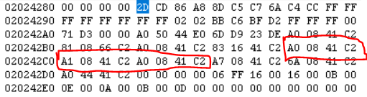

Decryptions for EV:

**GROWTH SECTION(12 bytes):**

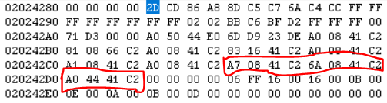

Decryptions for Growth:

C2 41 08 A7 ^ **C2 41 08 A0  
  
ALEX: TO CHANGE SPECIES FROM SQUIRTLE (007) TO WARTORTLE (008)  
 XOR first 4 bytes w/ key**

**Add one to the result**

**XOR the 4 bytes w/ key again**

**Get the result and compare with original 4 bytes, change to match the new**

**Add one to the check sum**

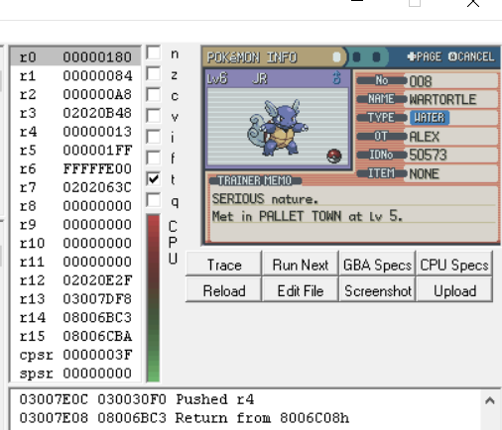

Status Condition: 4 bytes, offset 80-83: 00 00 00 00

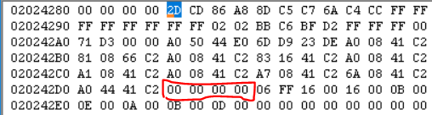

Level: 1 byte, offset 84: 06

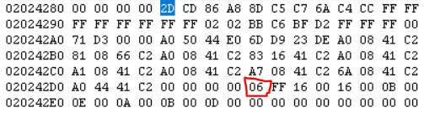

Pokerus remaining: 1 byte, offset 85: FF

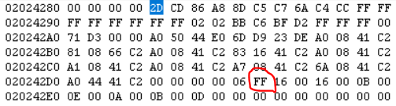

Current HP: 2 bytes, offset 86-87: 00 16

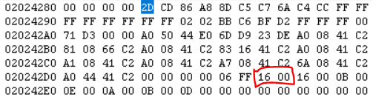

Total HP: 2 bytes, offset 88-89: 00 16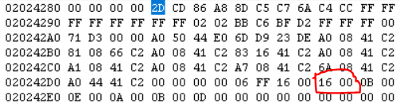  
  
Attack: 2 bytes, offset 90-91: 00 0B

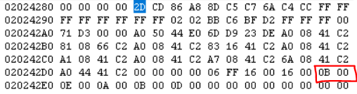  
  
Defense: 2 bytes, offset 92-93: 00 0E

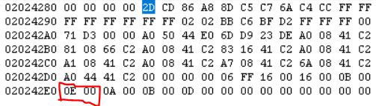

Speed: 2 bytes, offset 94-95: 00 0A

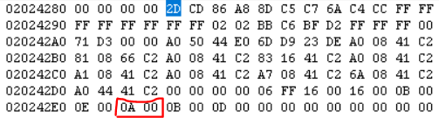

Sp. Attack: 2 bytes, offset 96-97: 00 0B

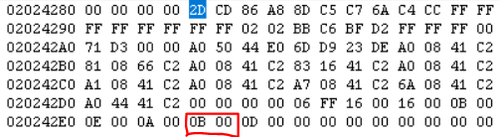

Sp. Defense: 2 bytes, offset 98-99: 00 0D

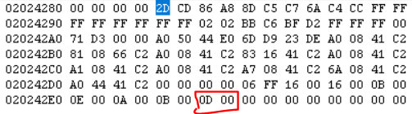

**Encryption of Data Section**

Squirtle personality value: A8 86 CD 2D = ‭2,827,406,637‬ mod 24 = 21  
Substructure order: MAEG

Trainer name: ALEX -> BB C6 BF D2

Trainer ID: 50573 shows on screen -> C5 8D, 6A C7 C5 8D represents whole ID

Decryption key: Original trainer ID number must be XORed with personality value

OT ID 0x6A C7 C5 8D -> ‭0110 1010 1100 0111 1100 0101 1000 1101‬

PERS 0xA8 86 CD 2D -> ‭1010 1000 1000 0110 1100 1101 0010 1101‬

DECRYPTION KEY:

OT ID ^ PERS -----------> ‭1100 0010 0100 0001 0000 1000 1010 0000‬ **= 0x‭C2 41 08 A0‬**

**At time of right after first rival battle save, checksum = D3 71**

The encrypted 48 bytes:

First 12 (Misc)  
Second 12 (Attacks)  
Third 12 (EV)  
Fourth 12 (Growth):

